## Prep for Meeting with Dr Hansung Kim:

### What I did:

1. Continued refining and debugging the pipeline, focusing on depth map enhancement and mesh generation.
2. Set up and debugged Steam Audio components in Unity (from Mona, its better to use baked instead of realtime, also what S3A uses, the only option for Steam Audio atp)
3. Created helper unity scripts for model dimension calculation and positioning.
4. Standardized scene scaling ratio and probe positioning and alignment for 5 evaluation scenes, table and instruction from week 4 for reference.

## Dimension (x, y, z) of scene meshes from original enhance360.py and 360monodepth to calculate scale ratio needed as follows:

1. KT – (4.16, 2.08, 5.44) enter scale (0.83, 1.28, 1.22) , align corner 2,
2. MR – (4.64, 1.84, 5.28), first rotate -90, enter scale (1.06, 1.27, 0.92), align corner 3
3. LR – (5.12, 2.08, 5.60), enter scale in table, align corner 0, swap X and Z for coords place.
4. ST – (6.08, 2.08, 6.40), first rotate -90, enter scale (2.67, 3.125, 2.39)
5. UL – (4.48, 1.92, 4.24), enter scale in table, align corner 0

|  |  |  |  |
| --- | --- | --- | --- |
| Scene and ratio (x, y, z) | Cam/Listener coords | Audio/Source coords | Ground Truth Dimen |
| KT (0.83, 1.28, 1.22) | (4.100, 1.705, 1.585) | (1.953, 1.676, 1.982) | (3.46, 2.67, 6.64) |
| MR (0.92, 1.27, 1.06) | (2.12, 1.00, 0.33) | (2.12, 1.00, 3.00) | (4.28, 2.33, 5.61) |
| LR (0.99, 1.39, 1.01) | (2.55, 1.08, 2.79) | (0.51, 1.20, 2.80) | (5.05, 2.90, 5.64) |
| ST (2.39, 3.125, 2.67) | (6.94, 1.50, 5.00) | (4.94, 1.50, 5.00) | (14.55, 6.50, 17.08) |
| UL (1.16, 1.52, 1.31) | (3.58, 1.07, 2.27) | (1.32, 1.07, 2.24) | (5.20, 2.91, 5.57) |

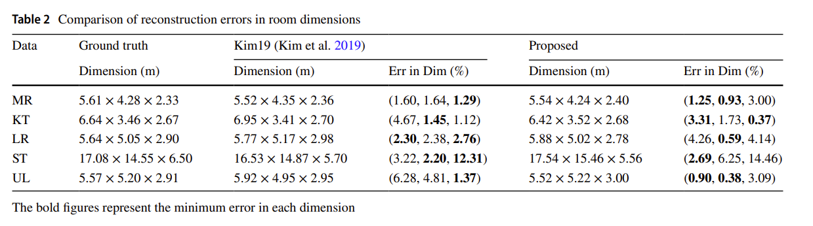

From <https://doi.org/10.1007/s10055-021-00594-3>, in Z, X, Y ( Length, Width, Height).

1. Generated audio for all scenes and set up the audio recording process (using external software: Audacity, Mona uses Wavepad)… concerns regarding audio compression?
2. Organized RIR analysis folders and modified MATLAB scripts for compatibility (absolute path to relative).
3. Reorganised GDP unity project folders to be more clear and easier to navigate. (scene folders, _scripts etc WIP)
4. Began troubleshooting EDT/RT60 analysis issues.

### Problems encountered (unsolved):

1. Issues with mono depth enhancement and mesh quality. -> fix_limits function in preproc is the culprit, it causes the issue on close limits, but needed for far limits (for mirrors and proper room scale)
2. ModelDimension calculation bugs in Unity. (it shows dimension depending on the axes, but the model can be on wrong rotation initially, giving wrong width and length reversed.)
3. Persistent problems with audio analysis results, despite trying various audio settings. (tried, trimmed, higher volume, different software), EDT and RT60 is too high.

### Plan for following week:

1. Continue investigating and resolving EDT/RT60 analysis issues. (test other scenes, could be isolated KT scene issue? It seems EDT is most problematic, find out how EDT calculation works, is it due to audio reverb delay bug? )
2. Further optimize the audio recording and analysis process (if needed)
3. Refine Unity project organization and Steam Audio settings. (standardisation/constant for all scenes? Or have proper table/list to refer.
4. Explore additional methods for improving mono depth map quality. (delve deeper into fix_limits function and modify for mono, monodepth map looks good, just incompatible with edgenet as noted by GDP, just CV problem atm)
5. Implement automation for audio baking in Unity.
6. Create separate Unity scenes for VR and non-VR demos.
7. Add more immersive elements (e.g., Rachel and Joao) to the VR demo. (following S3A)
8. Continue working on pipeline optimization, including Docker clutter removal and LiDAR file management.

## Meeting with Dr. Hansung notes:

* Continue with plan
* No meeting next week. (next meeting maybe around 6/7th August)
* Finish audio evaluation and analysis perfectly first (with graph etc), Mona’ SSC part a bit different right now so optional instead